Letter of Opposition
to Proposed Rezoning and Development RZ PD 22-0865. 5500 Memorial Hwy, Tampa: Folio # 11994.0100

Dear Hearing Master:

Surrounding Property Owners Received Letter of Notice on July 2nd, 2022, and comments required to be received 14 days PRIOR to July 25, 2022 Hearing date, only allowed owners 5 DAYS to respond via Mail, in-person, or email; or potentially retain and engage Legal Counsel. In addition, the Sweetwater Creek Property Owners Association (SCPOA) was not notified as required in the Procedures for Amendments for Official Zoning Atlas part 10.03.02 (02-0865 HOA 04-28-22.pdf). We, therefore, request the Hearing Master consider an Extension of the Hearing Date, to provide impacted parties sufficient time to respond and to ensure Applicant’s Representative conducts the neighborhood meeting as requested by SCPOA on July 7, 2022.

The Sweetwater Creek Property Owners Association (SCPOA) stands in opposition to the proposed rezoning and development RZ PD 22-0865 at 5500 Memorial Hwy, with frontage on Sweetwater Creek waterway.
The community objects to this development on several legal and policy grounds.
The Hillsborough County Comprehensive Plan, (Page One) states that the Goal is to “Ensure the character and location of land uses optimizes the combined potentials for economic benefit and the enjoyment and the protection of natural resources while minimizing the threat to health, safety and welfare posed by hazards, nuisances, incompatible land uses, and environmental degradation.” – Comprehensive Plan for Unincorporated Hillsborough County Florida-Future Land Use.
The Hillsborough County Local Mitigation Strategy (LMS) ensures Public Safety in the event of a natural disaster including evacuations, shelter planning, and evacuation routes. None of which were addressed in the rezoning application.
The proposed development violates specific laws and regulations pursuant to Hillsborough County Documents including the Comprehensive Plan Policy, Local Mitigation Strategy, and/or County Level of Service Reports as noted below.
1) Density - This rezoning request is inconsistent with Comprehensive Plan Policy 7.1 in that it vastly exceeds the maximum possible levels of residential densities for its designated RES-20 Future Land Use (FLU) category. In addition, the proposed rezoning from BPO to PD inaccurately claims to be a Commercial Apartment disingenuously citing to Municipal Code Sec. 6.11.16 (Apartment, Commercial) in order to add additional density for the project.
2) Coastal High Hazard Area (CHHA) - The site lies WITHIN a CHHA and this rezoning request is inconsistent with the county’s Coastal Management Objectives and Policies including Comprehensive Plan Policy 7.3 which indicates “flexes to increase residential density are not permitted in the Coastal High Hazard Area”. A CHHA designation makes this site particularly vulnerable to the effects of coastal flooding from tropical storm events and is defined by Florida Statute 163.3178(2)(h)9.
3) Natural Hazard Mitigation - The rezoning request is inconsistent with the county’s goals and objectives to protect the public health, safety, and welfare of those in high-risk areas as laid out in Comprehensive Plan Policies 10.9, 10.10, 10.11, and 10.12. Additionally, the requested PD is in direct conflict with the Hillsborough County Local Mitigation Strategy (LMS) to reduce death, injuries, and property losses caused by natural hazards in Hillsborough County—a requirement for eligible for federal hazard mitigation funding.
4) Environmental Impact - The rezoning request is also inconsistent with Comprehensive Plan Policy 47.2. The site is located on historical Sweetwater Creek, feeding directly into Old Tampa Bay (OTB). OTB is considered an impaired waterway and is rapidly losing seagrass due to nutrients entering the waterway from nonpoint sources. Elimination of proper setbacks will add impervious surface area and increase nutrient runoff. Comprehensive Plan Policy 47.2 states that the Proposed Development must have incorporated an Environmental Management Plan (EMP). To our knowledge, an EMP of the planned development has NOT been conducted. There is the potential impact or violation of the Florida Department of Environmental Protection (FDEP) 1996 Mangrove Trimming and Preservation Act (sections 403.9321-403.9333, F.S.) and the Endangered Species Act of 1973. Sweetwater Creek is categorized as an impaired waterway by the South Florida Water Management District and is on the US Environmental Protection Agency’s 303(d) list.
5) Traffic Impact – According to the 2020 Hillsborough County Level of Service Report Memorial Highway is currently rated an “F” for its Daily Level of Service (LOS) and is 7% beyond road capacity. The Applicant has NOT submitted sufficient transportation analysis to demonstrate that there is adequate capacity on the surrounding roadway network to support the proposed 329 unit dwelling without requiring off-site improvements.

We respectfully request the Hearing Master and zoning committee DOES NOT RECOMMEND rezoning request RZ-PD 22-0865.

In addition, given the limited response time, we are actively continuing to research additional potential impacts of the proposed rezoning to the surrounding communities. Any additional time or continuance of the hearing would be welcomed.

Sincerely,

Michael P. Jordan, President
Sweetwater Creek POA

APPENDIX – 1

1. Density
This rezoning request is inconsistent with Comprehensive Plan Policy 7.1 in that it vastly exceeds the maximum possible levels of residential densities for its designated RES-20 Future Land Use (FLU) category. The density of buildings and occupants being proposed is substantially higher that regulations and code, especially given the flooding risk of this storm zone area and elevation, and should be denied on its face.

  - County Policy
    - Future of Hillsborough: Comprehensive Plan for Unincorporated Hillsborough County, FL. Future Land Use Comprehensive Plan Policy 7.1 states:

The Future Land Use Map shall be used to make an initial determination regarding the permissible locations for various land uses and the maximum possible levels of residential densities and/or non-residential intensities, subject to any special density provisions, locational criteria and exceptions of the Future Land Use Element text.

    - Municipal Code: Sec. 6.11.16. - Apartment, Commercial states:
To further the provision of affordable housing and promote vertically mixed-use development in certain commercial and office zoning districts, commercial apartments shall be allowed in the BPO, CN, CG, SPI-UC-1 and SPI-UC-2 zoning districts, as well as in PD (Planned Development) zoning districts which generally permit such district uses. Commercial apartments shall meet the following criteria:

- Commercial apartments shall be located within a building containing a nonresidential use. The entire first story of the building shall be devoted to nonresidential use only, apart from entrances, stairways, elevators and mechanical equipment serving the commercial apartments. Commercial apartments shall be regulated on the basis of floor space rather than units per acre. Floor space devoted to commercial apartments shall contribute to site FAR (floor area ratio) calculations as follows. In cases where the commercial apartment space does not exceed 6,000 square feet or the amount of nonresidential floor space within the building, whichever is less, the commercial apartment space shall be excluded from site FAR calculations. In cases where the floor space devoted to commercial apartments exceeds 6,000 square feet or the amount of nonresidential floor space within the building, whichever is less, the amount of commercial apartment space in excess of the lesser figure shall be included in site FAR calculations. In all cases the nonresidential floor space in the building shall fully contribute to site FAR calculations.
- Off-street parking requirements shall be separately calculated for the non-residential component and the residential component of the building, and the greater number of required parking spaces shall be provided.
- A ten percent increase in parking lot landscaping and one additional canopy type tree for every two apartments shall be required.
- Buffering and screening for the parcel on which the commercial apartments are located, as well as for development on adjacent parcels, shall be provided as if no commercial apartments exist.
(Ord. No. 00-21, § 2, 5-18-00; Ord. No. 02-13, § 2, 8-1-02; Ord. No. 08-29, § 2, eff. 2-1-09; Ord. No. 09-62, Item M, 10-26-09, eff. 2-1-2010)

  - Applicant Request

The Scottish Rite Temple Association, in “partnership” with private real estate development corporation the Onicx Group (hereafter referred to as the “Applicant”), is requesting to rezone the property located at 5500 Memorial Highway from Business Professional Office (BPO) to Planned Development (PD). The PD is located within the RES-20 Future Land Use (FLU) categories and within the Town & Country Community Plan Area. The 8.46-acre tract is currently developed with the Scottish Rite Temple and a parking lot. The applicant is proposing development of a 25,000 square foot temple, 4,500 square feet office building and 246,888 SF dense residential development. The primary structure on the proposed PD is 329-unit, four story apartment complex located along the Sweetwater Creek waterfront. To accomplish the proposed plan the Applicant requires several variations to Land Development Codes. The variances being requested include:

  - Density Variance - Request for almost double the maximum allowable density (195%) for the site’s designated future land use category of RES-20.

  - Commercial Apartment Variance – Applicant is also requesting that the county wave the definition of commercial apartment, to allow them to deceptively build under a designation for which they clearly do not belong, in a veiled attempt to evade county density rules.

  - Impact

The Scottish Rite Property is within the RES-20 future land use category, which allow for residential uses at maximum density of 20 du/acre. Additionally, the site is located within the Coastal High Hazard Area, making it an area explicitly discouraged from developing at the higher end of the permissible density range. The resulting MAXIMUM permissible density of the 8.46 acres site is 169 units. The applicant is proposing a 329-unit apartment complex on the site—nearly double the MAXIUM permissible density its designated RES-20 FLU category.

The Applicant is also requesting that county waive its definition of “commercial apartment” (Hillsborough County Land Development Code 6.11.16A) to allow them to calculate density on the basis of Floor Area Ratio as opposed to units per acre. The Applicant is clearly trying to use this false designation to override and momentously exceed the counties maximum attainable density regulations.

According to Hillsborough County’s Future Land Use Reference Guide:
“Future Land Use Designations are supported and governed by the Goals, Objectives, and Policies of the jurisdictional Comprehensive Plans. The Plans describe each land use category’s intended purpose and character and define allowable densities and intensities of development. Under Florida law, all comprehensive plans must have a FLUM and all land use regulations and capital improvements must be consistent with that FLUM. In short, the FLUM is a legally binding prescription for future growth, as well as a guide to provide for land use consistency and change.”
This rezoning request and its associated variance requests are inconsistent with the County’s Comprehensive Plan, Hillsborough County Land Development Codes, and Florida law. Given the site’s location with a CHHA, this rezoning request is also inconsistent with the stated purpose of County Hazard Mitigation plan to “reduce death, injuries, and property losses caused by natural hazards in Hillsborough County”. We object to the rezoning request on these grounds and respectfully request that Application Number 22-0865 be denied.

APPENDIX – 2

2. Coastal High Hazard Area (CHHA) – (see map below section 2.4)
This proposed development site lies WITHIN the Coastal High Hazard Area (CHHA) and this rezoning request is in clear contradiction to the Coastal Management Objectives and Policies of the county including Comprehensive Plan Policy 7.3 which states “flexes to increase residential density are not permitted in the Coastal High Hazard Area”.
A CHHA is particularly vulnerable to the effects of coastal flooding from tropical storm events and is defined by Florida Statute 163.3178(2)(h)9 as the area below the elevation of the category 1 storm surge line as established by a Sea, Lake, and Overland Surges from Hurricanes.

2.1. Comprehensive Plan Policy 7.3

The Coastal High Hazard Area (CHHA) map defines an area that has a high probability of hazards during a hurricane, high winds and or flood water. The goal of this CHHA policy is lower density in this area so fewer people in these areas are placed in serious danger and need to be evacuated.

Under zoning, increased density may be pursued, but NOT in a Coastal High Hazard Area. In the CHHA policy density cannot increase due to substantial risks. This proposed development is clearly located in a CHHA. To increase density is in direct contradiction to CHHA guidelines and would place the residents at risk.

CHHA further states… in order to further direct residential population growth from the vulnerable coastal areas of the county, all density bonuses outlined in the Future Land Use Element shall not be applicable to properties within the Coastal High Hazard Area.

Development that has significant environmental conditions on-site must also be in conformance with the objectives and policies of the Conservation Element. Development proposed within the Coastal High Hazard Area must also be in conformance with the Goals, Objectives and Policies found in the Coastal Management Element. (See https://planhillsborough.org/coastal-management-element-2/ )

Objective 6 of CHHA: Residential land uses within the CHHA shall be limited to those areas which are planned to accommodate such development through the provision of adequate public facilities and services. Such development must meet storm velocity standards and be provided with adequate hurricane evacuation capability.

Comprehensive Plan Policy 7.3
The land use category boundaries may be considered for interpretation as flexible boundaries in accordance with the Flex Provision as follows:

- Through application of the flex provision, the land use category boundaries shall be deemed to extend beyond the precise line to include property adjoining or separated by a man made or natural feature from the existing boundary line.
- The line may be relocated a maximum of 500 feet from the existing land use boundary of the adopted Land Use Plan Map. Right-of-Way is not included in the measurement of the 500 foot flex.
- No new flexes can be extended from an existing flexed area.
- All flexes must be parallel to the land use category line.
- Flexes are not permitted in the Rural Area or in areas specified in Community Plans. Flexes are also not permitted from the Urban Service Area into the Rural Area. All flexes in the Rural Area approved prior to July 2007 are recognized and are not to be considered non-conforming.
- Flexes to increase residential density are not permitted in the Coastal High Hazard Area. Flexes are not permitted from a municipality into the unincorporated county.
- A flex must be requested as part of planned development or site plan oriented rezoning application. Major Modification to approved zoning that changes the intensity, density or the range of uses will require that the previous flex request be re-evaluated for consistency and a new flex request may be required.
- Applicants requesting a flex must provide written justification that they meet the criteria for a flex as outlined below.
- The Board of County Commissioners may flex the plan category boundary to recognize or grant a zoning district which is not permitted in the land use category but lies within the distance of a conforming land use category, as described above. Prior to the determination by the Board of County Commissioner, the staff of the Planning Commission shall make a recommendation on the consistency of the request with the Comprehensive Plan.

2.2 2021 Florida Statute 163.3178(2)(h)
Designation of coastal high-hazard areas and the criteria for mitigation for a comprehensive plan amendment in a coastal high-hazard area as defined in subsection (8). The coastal high-hazard area is the area below the elevation of the category 1 storm surge line as established by a Sea, Lake, and Overland Surges from Hurricanes (SLOSH) computerized storm surge model. Application of mitigation and the application of development and redevelopment policies, pursuant to s. 380.27(2), and any rules adopted thereunder, shall be at the discretion of local government.

2.2. Applicant Request

While the Coastal High Hazard Area (CHHA) was created to minimize the impact and risk of disasters by restricting the amount of dwelling units and inhabitants per acre, this proposed development would do exactly the opposite; almost doubling the allowable density (number of dwelling units; apartments, houses) in this high hazard area This is not allowed per the established zoning and code. In fact, this CHHA zone does not even allow for the 20 units per acre density.

This application proposes to avoid the limitation of the density capped under CHHA by stating they are waiving the units/ acre and instead utilizing Floor Area Ratio (FAR) for the count. According to state of Florida and Hillsborough County this is not acceptable for the CHHA.

More specifically, by changing their application to state that they will use the square footage rule (FAR .75) and totally eliminate the units per acre rule, which is what governs most of the zoning densities. This would then skirt the protections which the CHHA is supposed to enforce, putting future occupants of the project and property in danger.
Overall, this development proposal is requesting to get approval for almost double the allowable density. This is something that is very difficult in any inland areas of Hillsborough County, let alone in a CHHA; an area that was designed and intended and mapped out to specifically not allow any high densities and to protect the citizens of our community.
(See: https://library.municode.com/FL/hillsborough_county/codes/land_development_code?nodeId=ARTVIDESTIMRE_PT6.11.00SPCOUS_S6.11.16APCO )

2.3. Impacts (see 2.4 graphic below showing aerial site at 1 meter elevation)

Tampa already ranks as the most surge-vulnerable city in the United States. Over time, we, as a community, must increase compliance with our Coastal Management policies, not retreat from them. This site is located on historical Sweetwater Creek, feeding directly into Old Tampa Bay; already considered an IMPAIRED WATERWAY due to high levels of fecal coliform and dissolved oxygen nutrients run off according to state of Florida Department of Environmental Protection studies.
Waterfront construction will also create siltation of Sweetwater Creek further damaging the environment of the water, and the ecological balance of the sea grasses, manatee, fish population and numerous birds that habitat the area, as well as damage to the navigation aspects of the waterway.
The elimination of proper setbacks adds impervious surface area and increases the nutrient runoff. Reducing these setbacks allows developers to make more money while taxpayers are required to pay for projects to clean up the same area.
Another effect of the CHHA designation is that the project site must be elevated (currently at 1 meter above water; see attached map) or flood proofed, which makes entirely practical sense, but is also fantastically expensive. Nevertheless, these CODEs and future land use and zoning criteria are designed to protect; not to arbitrarily waive rights so a developer can further profit from development.
2.4 Graphics
Unincorporated Hillsborough County
COASTAL HIGH HAZARD AREA (2021)
ADOPTED FUTURE LAND USE MAP SERIES
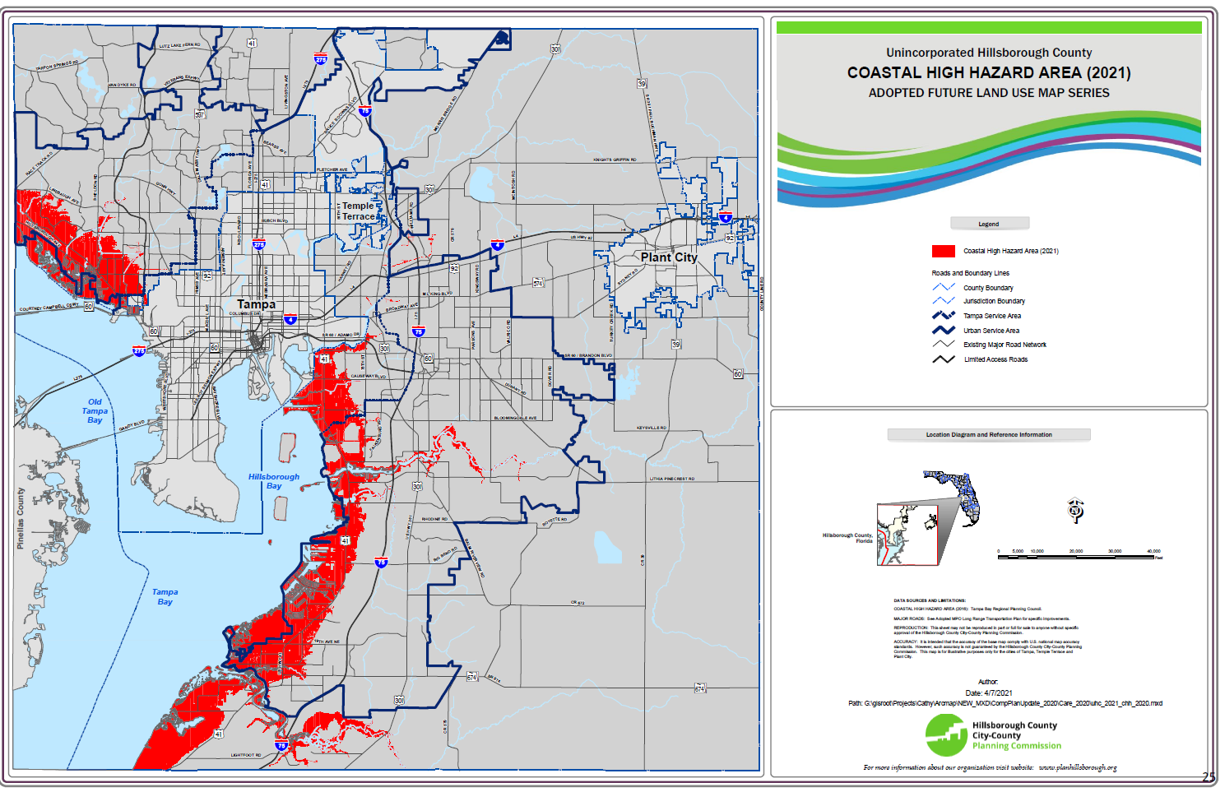

Proposed Site 1 Meter elevation above water level.
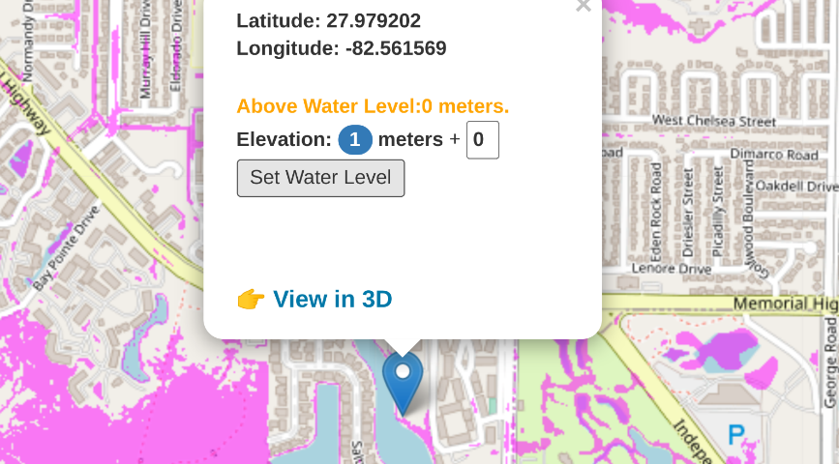

APPENDIX – 3

3 Natural Hazard Mitigation - The rezoning request is inconsistent with the county’s goals and objectives to protect the public health, safety, and welfare of those in high-risk areas as laid out in Comprehensive Plan Policy 10.9, 10.10, 10.11, and 10.12. Additionally, the requested PD is in direct conflict with the Local Mitigation Strategy (LMS) to reduce death, injuries, and property losses caused by natural hazards in Hillsborough County—a requirement for eligible for federal hazard mitigation funding.

The rezoning request does not adequately address the CHHA issues relating to Plan Policies listed below. Nor does it address the Hillsborough County’s Local Mitigation Strategy (LMS) issues on natural disasters and offers no guidance on Policy 10.11, and 10.12 for evacuation, shelter space and clearance times. Clearance times for all residents may increase due to the increased traffic burden (See Appendix 5).

As reported by Hillsborough County and WTSP news, there are currently only 55 Evacuation shelters in Hillsborough County, and the 2020 census shows 1.46 million county residents. It is doubtful these shelters can hold 27,000 people per shelter, but the proposed development will only add to the safety burden. (https://www.wtsp.com/article/weather/hurricane/tampa-hurricane-shelter-shortage/67-b96222f4-244f-4b02-8cae-471d8c537bfa )

3.1 Comprehensive Plan Policy 10.9, 10.10, 10.11, and 10.12
- Policy 10.9:
Continue to implement, review and amend, as needed, measures to restrict and eliminate inappropriate and unsafe development in the Coastal High Hazard Area (CHHA) through plan designated uses, zoning and density and intensity limitations.
- Policy 10.10:
Residential land uses within the CHHA will be limited to areas planned to accommodate such development through the provision of adequate public facilities and services.
- Policy 10.11:
Development proposals within the CHHA shall provide adequate data during the site plan review process to assess the impacts of the proposed development upon existing infrastructure within the Coastal High Hazard Area and level of service standards established for shelter capacity and clearance times.
- Policy 10.12:
Consider the impacts of new development on evacuation and shelter space standards within the CHHA during the development review process.

3.2 Hillsborough County Multi-jurisdictional Local Mitigation Strategy (LMS)
The overarching purpose for the county LMS is “to minimize the effects of any potential natural or manmade disasters on the community and its infrastructure;” however, using the new hazards and vulnerability analyses, goals were crafted along with specific directives to fully recognize the overall intentions of the county.
(https://www.hillsboroughcounty.org/library/hillsborough/media-center/documents/lms/plans/countywide-local-mitigation-strategy.pdf )

3.2 Applicant Request
The applicant request does not adequately address the Comprehensive Plan Policies listed above.

3.3 Impacts
The proposed development has not addressed the potential negative impacts on the safety of residents due to their request for a high density rezoning.
APPENDIX – 4

4. Environmental Impact - The rezoning request is also inconsistent with Comprehensive Plan Policy 47.2. The site is located on historical Sweetwater Creek, feeding directly into Old Tampa Bay (OTB). OTB is considered an impaired waterway and is rapidly losing seagrass due to nutrients entering the waterway from nonpoint sources. The elimination of proper setbacks adds impervious surface area and increases the nutrient runoff. Comprehensive Plan Policy 47.2 states that the Proposed Development must have incorporated an Environmental Management Plan (EMP). To our knowledge, an EMP of the planned development has NOT been conducted. There is the potential impact or violation of the Florida Department of Environmental Protection (FDEP) 1996 Mangrove Trimming and Preservation Act (sections 403.9321-403.9333, F.S.) and the Endangered Species Act of 1973. Sweetwater Creek is categorized as an impaired waterway by the South Florida Water Management District and is on the list of the US Environmental Protection Agency’s 303(d) list.

Federally Protected Mangrove habitat.
In addition, the proposed rezoning does not address the Florida Department of Environmental Protection (FDEP) 1996 Mangrove Trimming and Preservation Act (sections 403.9321-403.9333, F.S.) We respectfully request a Botanist report on the Mangrove prepared by a Certified Ecologist as certified by the Ecological Society of America; a Professional wetland scientist as certified by the Society of Wetland Scientists; and/or by a Certified Arborist, certified by the International Society of Arboriculture. (see picture below of Mangrove habitat). In addition, there is currently some invasive Brazilian Pepper on the proposed site. A reduction of the Mangrove habitat may also damage what remains as it is overtaken by the invasive species. The key point here being the Mangroves providing a cleaning and healthy waterway in Sweetwater Creek.
Protected Mangrove Habitat
Urban development is a major threat to mangrove habitats.
Due to the increasing pressure from rapidly expanding development along the coast of Florida, it is critical that mangrove habitats are protected from further destruction. Mangroves, seagrass beds, and coral reefs are all dependent upon one another, providing habitat for many aquatic plants and animals including those that are endangered and threatened. Mangroves also provide shoreline stability and protection from storm surge and erosion. These roles all support the local economies of many south Florida communities. Pressure to destroy remaining mangrove habitat is increasing due to the continued urban development along the coasts of Florida. – (University of Florida Museum https://www.floridamuseum.ufl.edu/southflorida/habitats/mangroves/conservation/)

In 1996, the Florida Department of Environmental Protection (FDEP) implemented the Mangrove Trimming and Preservation Act. This Act regulates the trimming and alteration of mangroves while also banning the use of herbicides and other chemicals used to defoliate mangroves. Mangroves cannot be removed, trimmed, or disturbed without a permit from the Florida Department of Environmental Protection.

There is no mention of protecting the mangroves, an application to the Florida Department of Environmental Protection for their decrease in “setback.” Often builders ignore, or have a subcontractor “Play dumb” and “accidentally” remove protected vegetation to improve their project’s access to a waterway. Often building in a “fine” into the development costs of the project.

As shown below, there is a large and lush Riparian Mangrove that contains species Laguncularia racemosa (white
mangrove), Rhizophora mangle (red mangrove), or Avicennia germinans (black mangrove).
Mangrove Habitat on proposed development site.

The 1996 Mangrove Trimming and Preservation Act (sections 403.9321-403.9333, F.S.)
403.93271 Applicability to multifamily residential units.
(1) When trimming under s. 403.9327(1)(a) occurs on property developed for multifamily residential use, the 65-percent shoreline trimming limit must be equitably distributed so that each owner's riparian view is similarly affected.
(2) If it is necessary to trim more than 65 percent of the mangroves along the shoreline in order to provide a water view from each unit, the department or delegated local government may authorize a greater percentage of trimming under s. 403.9327(1)(a). This subsection applies only to property on which multifamily residential units exist as of June 1, 1996.
History. s. 7, ch. 96-206.

The proposed development with its request for a minimal setback in the rezoning, may impact several endangered and threatened species according to the Endangered Species Act of 1973, but also wildlife indicating a recovering waterway and environment.

Potential Endangered and Threatened Species from the proposed development pursuant to Act of 1973
The Endangered Species Act of 1973, 16 U.S.C. ch. 35 § 1531 et seq., was designed to protect critically imperiled species from extinction as a "consequence of economic growth and development un-tempered by adequate concern and conservation".

Manatee, West Indian Entire (Trichechus manatus)
Sweetwater Creek in the area of the proposed development is a known Manatee Breeding ground. In late fall, and early spring the Manatees form an aggregation in the shallow waters of Sweetwater Creek. This was noted on November 10, 2014 when the Florida Wildlife Commission-Marine Mammal Research & Rescue saved a Baby Manatee that was injured by a crab trap in the area, along with her mother. See pictures below.
The proposed development may increase pollution, sewage, and other water runoff potentially damaging to the Manatee habitat. This is a major problem as the Manatee is Endangered per the Endangered Species Act.
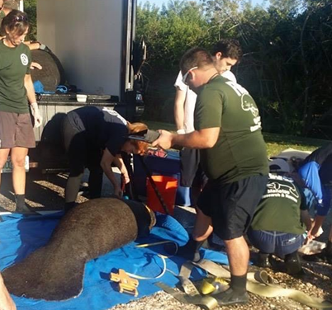 a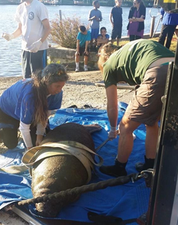
FWC Marine Mammal vessels in Sweetwater Creek. FWC staff tending to Sweetwater Creek Manatees.

The red-cockaded woodpecker (Picoides borealis)
The red-cockaded woodpecker (Picoides borealis) has been a federally protected endangered species since 1970 and is federally listed as endangered in Florida. – Florida Fish and Wildlife Conservation Commission.
As the Scottish Rite does not keep up with their landscaping, there are many dead palm trees and other trees that have attracted a series of Woodpeckers to the Property Area, including the Endangered Red-Cockaded Woodpecker (Picoides borealis). Below is a picture of a woodpecker taken at 4203 Saltwater Blvd, by the owner on May 3, 2022.
The proposed development may further endanger the woodpecker habitats and fall in violation of the Endangered Species Act.

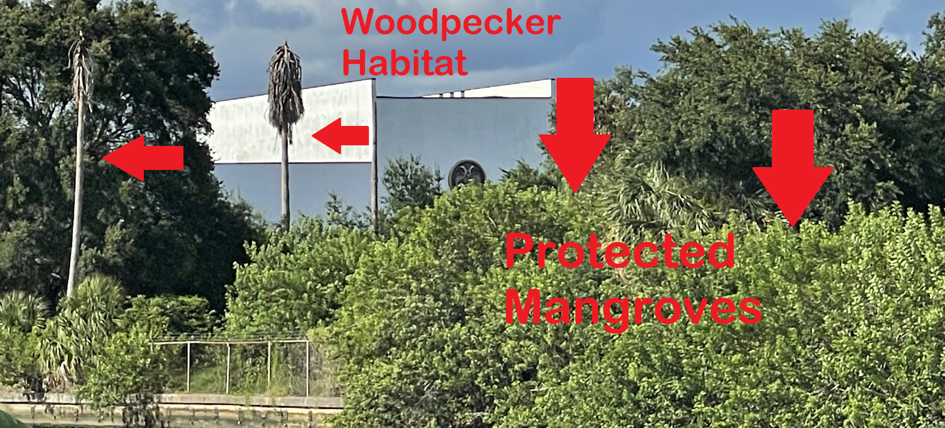

Seagrass, Johnson's (Halophila johnsonii)
The proposed development may exacerbate the continued degradation of the water quality in Sweetwater Creek (as noted below relating to stormwater runoff, sewage overflow, and high e-coli counts by SFWMD studies) may have an impact on seagrass and seaweed, which are also the primary food for the Florida Manatee noted above. In addition, without an in-depth study, the seagrass noted to live in the tidal waterways are a threatened plant species in Florida pursuant to the Endangered Species Act.

Other Noted wildlife in the Sweetwater Creek area, including evidence of Turtle nesting on the proposed development land is noted below:

Terrapin Turtle Nesting loss
The wetlands on the south end of Scottish Rite are not owned by them and should be better protected. It is currently fenced off from the Scottish Rite property, but the fencing has gaps in it. Meanwhile, Sweetwater Cove residents have used the 'set-aside' for fishing, drinking, camping (with fires), littering, and general traipsing around. The sum of these environmental factors should be of great concern to the County Staff. A terrapin study was done ten years or so in Sweetwater Creek, with a few sightings. Residents note they have not seen a terrapin in years.
Increase in Black Tipped Shark population (water health)
(FDOT Stormwater Runoff Project 439206-1-52-01)
In 2019 the Florida Department of Transportation (FDOT) cut a large hole in the eastern section of the Courtney Campbell Causeway just south of Sweetwater Creek to “Stormwater Runoff is getting trapped in the north part of the bay and the pollutants are unable to flush, preventing the natural treatment process from occurring. Over the years this has had a dramatic impact on the health of the Bay.” This was done to provide more water circulation and restore tidal flows, to provide environmental benefits for years to come especially in relation to Water Quality, Circulation, and generating Seagrass growth in the area.

Sweetwater Residents note the increase of aquatic life, including a new species of Black Tipped Sharks in the area as a result of the $13.5 million dollar FDOT project. The proposed development would decrease the gains made in recent years to the water quality of Sweetwater Creek.
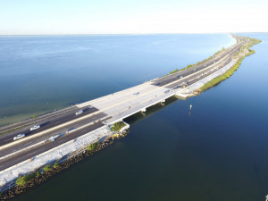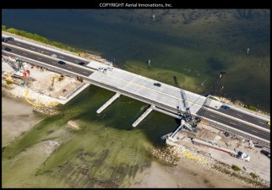
FDOT Water Quality Project under Rt. 60 Courtney Campbell Causeway. – Source: 439206-1-52-01

Seawall collapse set-back issues
There are reasons for setback restrictions. Not only as a buffer for light, noise and stormwater pollution, but also to guard against sea-wall collapse in this case. Without setback and appropriate landscaping and safeguards against light and sound pollution, the resident wildlife along with adjoining neighborhoods are heavily and detrimentally impacted.

Stormwater runoff
Stormwater runoff is the single biggest environmental problem in Hillsborough County. Lakes, streams and bay. In 2004 & 2005 Hillsborough County, at great time and monetary expense, did a Canal Advisory Board (which I served on) and came up with many recommendations. None have really been implemented, at least as intended, so the problem gets worse. They say 'bordered by navigable waterway' and that is not at all true. Our estuaries are stormwater channels, with mostly unfiltered run-off. Sweetwater Creek was re-routed to serve stormwater drainage needs, leaving lower Sweetwater Creek to handle north of the airport. Some improvements were made by Berkeley Prep when they built on both sides of the canal, but still with a heavy rain, the trash and silt seems thick enough to walk on. Also a fact, our estuaries feed Tampa Bay, and it will only improve when the estuaries improve, which will only happen with stormwater control.

"Hillsborough County should promote the use of Low Impact Development (LID) practices. The practices can be used in conjunction with new development as well as retrofitting existing communities. LID is simple and effective. Instead of large investments in complex and costly centralized conveyance and treatment infrastructure, LID allows for the integration of treatment and management measures into urban site features."
- (cited https://www.edocr.com/v/6j0vqr9q/jackberlin/canal-dredging-final-recommendations )

The Scottish Rite Property currently is, in fact, a help to the surrounding ecosystem with its large permeable grass field which absorbs and filters water. It could be enhanced to do much more good, but the zoning proposal make it a large additional run-off site.

Recommended Sediment Abatement and Remediation (SAR) Program.
This recommendation would create a program tasked with initiating projects that have the effect of reducing downstream sedimentation within the coastal residential canal areas as well as restoring the navigable depths within the affected coastal residential canal communities and the traditional connecting canals to navigable waters of Tampa Bay proper. (See stormwater runoff citation)
Sweetwater Creek Water Health and Dredging History

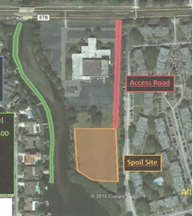
In the 1990s, Sweetwater Homeowners paid for landscaping along the canal over two separate landscaping projects, and subsequently, without any follow up care over the years, is yet again an eyesore, with the sea wall invaded with Brazilian Pepper.

Also, in May 2017, Sweetwater Homeowners and the Scottish Rite had an agreement in principle that Sweetwater Homeowners would pay for dredging of Sweetwater Creek, which would benefit all adjacent properties, and the 'in-kind' contribution from Scottish Rite would be to allow the back of their field to be a 'spoils' area, to be trucked away and restored after dewatering.

The Scottish Rite reneged on that understanding, forcing us to truck out wet dredge loads, for approximately $100,000 less in silt removal. The original dredge plan submittal to Hillsborough County is attached.

In addition, in revisiting the "navigable waterway" any development adjacent to Sweetwater Creek, must not only repair any spills and damage from proposed construction, but also must, in fact, do maintenance dredging that they hampered us from doing in 2018.

Sweetwater Creek EPA CWA Section 303(d) Impaired Waterway
Sweetwater Creek Water Testing Analysis by the SOUTH FLORIDA WATER MANAGEMENT DISTRICT (SFWMD) identified that the Sweetwater Creek waterway is Impaired as to Enterococci (Impaired Waters Rule).

The finding of the test states:
This waterbody is impaired for this parameter based on the number of exceedances for the sample size and anthropogenic sources have been identified using land use. This parameter is being added to the Verified List and the department is requesting the Environmental Protection Agency (EPA) add it to the 303(d) List.

Cycle: 4. Group:1. OGC Case Number: 19-0657: Planning Unit Coastal Old Tampa Bay Tributary: Hillsborough County
WBID: 1570A Type: Estuary Waterbody Class: 3M
Cite: Comprehensive-Verified-List_06032020_0.pdf SFWMD

The term "303(d) list" or “list” is short for a state’s list of impaired and threatened waters (e.g. stream/river segments, lakes). States are required to submit their list for EPA approval every two years. For each water on the list, the state identifies the pollutant causing the impairment, when known. In addition, the state assigns a priority for development of Total Maximum Daily Loads (TMDL) based on the severity of the pollution and the sensitivity of the uses to be made of the waters, among other factors (40 C.F.R. §130.7(b)(4)).

In general, once a water body has been added to a state’s list of impaired waters it stays there until the state develops a TMDL and EPA approves it. EPA reporting guidance provides a way to keep track of a state’s water bodies, from listing as impaired to meeting water quality standards. This tracking system contains a running account of all of the state’s water bodies and categorizes each based on the attainment status. For example, once a TMDL is developed, a water body is no longer on the 303(d) list, but it is still tracked until the water is fully restored.
Source: Florida Department of Environmental Protection

Related Documents and Links
- Final Report: Fecal Coliform TMDL for Brushy Creek, Sweetwater Creek, Rocky Creek, Lower Rocky Creek
- Final Report: Mercury TMDL for the State of Florida
- Lower Sweetwater Creek (WBID 1570A) Fecal and Total Coliform TMDL
- Lower Sweetwater Creek (WBID 1570A) Nutrients TMDL
Again, the proposed development will only lead to further degradation of the Sweetwater Creek waterway.

4.1 Comprehensive Plan Policy 47.2:
Development pursuant to this category must utilize a Planned Development zoning and incorporate an Environmental Management Plan (EMP). The EMP must be developed with input from local and regional agencies including, minimally, the Environmental Protection Commission of Hillsborough County, the Planning Commission and the Regional Water Supply Authority. The EMP shall provide for expanded environmental protections to a Regional Resource, enhanced open space, public water and sewer, public access to a Regional Resource, and enhanced water quality protections. The EMP shall further specify the methods of implementation, enforcement (such as deed restrictions to prohibit dumping, clearing, and disturbance of buffers), maintenance, and protection including the enhancement of buffers through pine reforestation planting and planting other native vegetation (as may be required for habitat mitigation) where pasture exists adjacent to a Regional Resource in order to achieve a density of 1du/2 ac.

4.2 Applicant Request

Comprehensive Plan Policy 47.2 states that the Proposed Development must have incorporated an Environmental Management Plan (EMP). To our knowledge, an EMP of the planned development has NOT been conducted.

4.3 Impacts

The negative environmental impacts of the proposed development could be devastating to the environment, wildlife, aquatic life, plant life, the community, and residents of the area.
APPENDIX – 5

5. Traffic Impact – According to the 2020 Hillsborough County Level of Service Report Memorial Highway is currently rated an “F” for its Daily Level of Service (LOS) and is 7% beyond road capacity. The proposed plan will most likely lead to excessive traffic congestion and safety concerns are likely. As shown on page 5 of the report, the volume to capacity ratio (v/c) exceeds 1.00 (the current v/c is 1.07), indicating that the counted volume exceeds the capacity of the road by 7%.

Traffic on Memorial highway is a disaster, and getting worse by the month, with a mile plus backup to the west of Dana Shores Blvd every weekday morning, with three schools within a few miles; and a mile plus back up to the east of Dana Shores Blvd (on both Memorial and Independence) every weekday afternoon. The proposed additional traffic ingress and egress is directly at the existing bottleneck of Memorial Hwy, which is Dana Shores Blvd and Independence.

5.1 2020 Hillsborough County Level of Service Report

Memorial Hwy “F” Rating for Daily Level of Service (LOS)
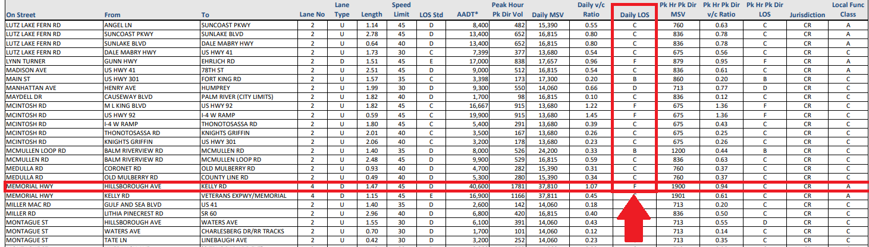

(Image 1) https://www.hillsboroughcounty.org/library/hillsborough/media-center/documents/public-
works/traffic/traffic-level-of-service-report.pdf

5.2 Applicant Request
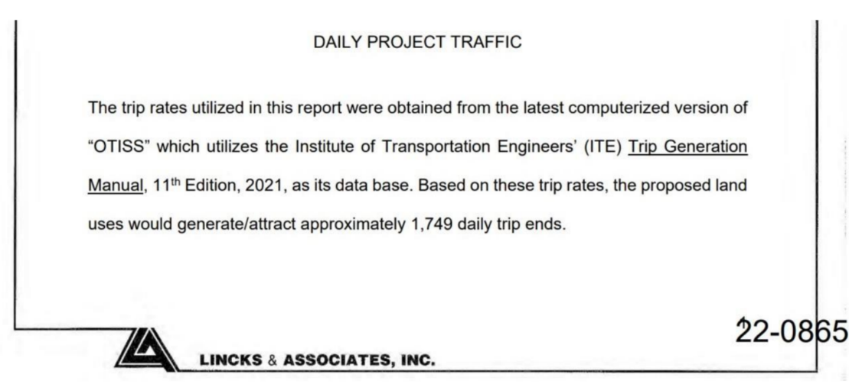
According to the Access Management Analysis for the proposed rezoning of the Scottish Rite site, 5500 Memorial Hwy, Tampa, FL 33634, the proposed land uses would generate approximately 1,749 additional daily trips on MEMORIAL HWY.

5.3 Impacts

According to the Daily Project Traffic image above, the Annual Average of Daily Traffic (AADT) on MEMORIAL HWY is approximately 40,600 vehicles on MEMORIAL HWY as of Oct. 2021. Add the 1,749 daily trips generated by the proposed project, and that becomes 42,349, exceeding the maximum daily trips of 37,810 trips by 12%, a 5% increase on the current v/c.

According to the Map Image Below – the Florida Department of Transportation's Florida Traffic Online Web Application – the AADT for MEMORIAL HWY was 39,000 daily trips in 2021, still exceeding the maximum of 37,810 trips established in Image 1. Add the 1,749 daily trips generated by the proposal, and it still raises the daily trip approximation to 40,749, an 8% spike over the maximum.
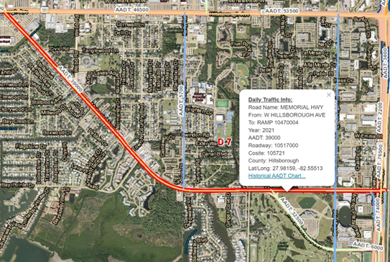

Given the significant impact that the proposed project can potentially cause to MEMORIAL HWY, a roadway with an existing traffic issue, the minimum action required should be an in-depth traffic study. The true effect of the project’s impact on traffic needs to be considered, and this project should not be approved until such an analysis is completed.

HILLSBOROUGH COUNTY CITY-COUNTY PLANNING COMMISSION, Gonzalez, Tatiana [12/1/2020]. Development in the Coastal High Hazard Area (CHHA) - A Best Practices Policy Analysis
Hillsborough County Development Service Additional / Revised Information Sheet, June 17, 2022, p. 5, as referenced at 22-0865 Rev SP 06-17-22.pdf
Available at https://planhillsborough.org/wp-content/uploads/2019/03/FLU-Reference-Guide.pdf [Accessed on 7-11-22].
Hillsborough County Multi-jurisdictional Local Mitigation Strategy 2020 Plan Update. Version 1.1 - February 2022. P i.

